/***********************************************

** File: Assignment4.sql

** Desc: Combining Data, Nested Queries, Views and Indexes, Transforming Data

** Author: Swati Susan Sathyan

** Date: 10/22/2023

************************************************/

QUESTION 1

a) List the actors (firstName, lastName) who acted in more then 25 movies.

# b) List the actors who have worked in the German language movies.

# Note: Please execute the below SQL before answering this question.

SET SQL_SAFE_UPDATES=0;

UPDATE film SET language_id=6 WHERE title LIKE "%ACADEMY%";

c) List the actors who acted in horror movies.

Note: Show the count of movies against each actor in the result set.

d) List all customers who rented more than 3 horror movies.

e) List all customers who rented the movie which starred SCARLETT BENING

f) Which customers residing at postal code 62703 rented movies that were Documentaries.

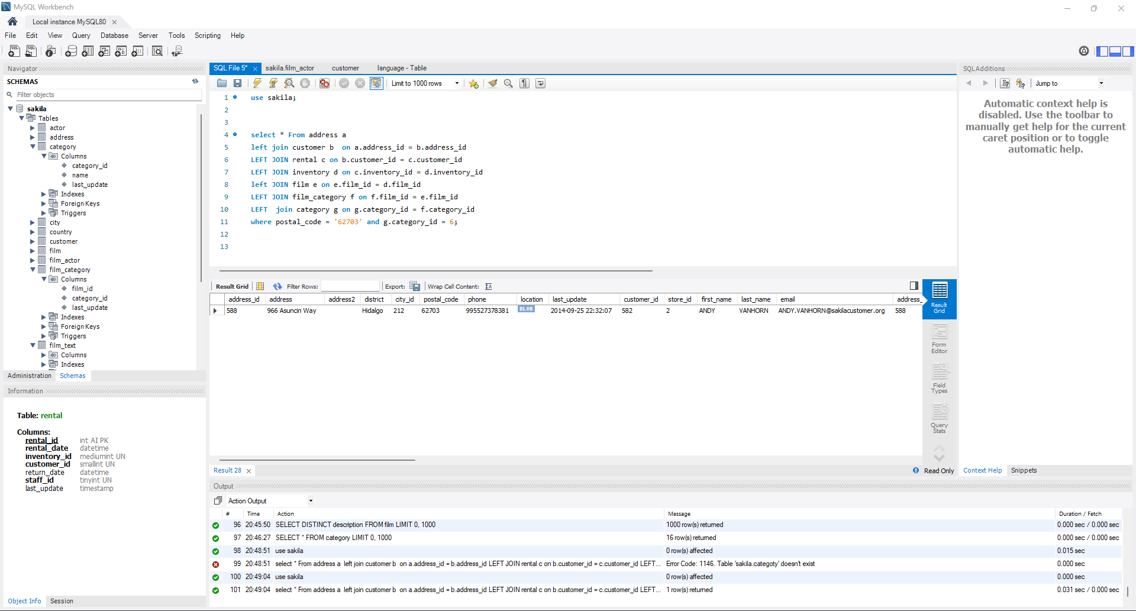

g) Find all the addresses where the second address line is not empty (i.e., contains some text), and return

these second addresses sorted.

h) How many films involve a “Crocodile” and a “Shark” based on film description ?

i) List the actors who played in a film involving a “Crocodile” and a “Shark”, along with the release year of the

movie, sorted by the actors’ last names.

j) Find all the film categories in which there are between 55 and 65 films. Return the names of categories and

the number of films per category, sorted from highest to lowest by the number of films.

k) In which of the film categories is the average difference between the film replacement cost and the rental

rate larger than 17$?

l) Find the list of all customers and staff given a store id

Note : use a set operator, do not remove duplicates

QUESTION 2

1. List actors and customers whose first name is the same as the first name of the actor with ID 8.

1. List customers and payment amounts, with payments greater than average the payment amount

c) List customers who have rented movies atleast once

Note: use IN clause

1. Find the floor of the maximum, minimum and average payment amount

QUESTION 3

a) Create a view called actors_portfolio which contains information about actors and films ( including titles and

category).

b) Describe the structure of the view and query the view to get information on the actor ADAM GRANT

QUESTION 4

1. Extract the street number ( characters 1 through 4 ) from customer addressLine1

1. Find out actors whose last name starts with character A, B or C.

1. Find film titles that contains exactly 10 characters

1. Find the number of days between two date values rental_date & return_date

